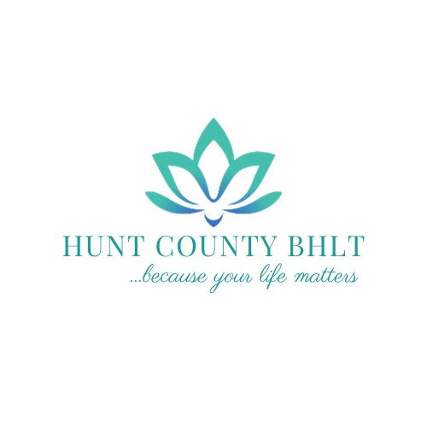
SILENT AUCTION DONATION FORM:
The Hunt County Behavioral Health Leadership Team Annual Golf Tournament Fundraiser

Jana Campbell – Director Telephone: (903) 453-6856
2801 Stuart St. Email: hcbhlt@gmail.com
Greenville, TX 75401 Donation Deadline: Sept 27th, 2024
Event Date: Friday, October 11th, 2024

DONATED ITEM INFORMATION:
DESCRIPTION: _______________________________________________________________ __________________________________________________________________________________________________________________________________________________________
RESTRICTIONS: ______________________________________________________________ __________________________________________________________________________________________________________________________________________________________
RETAIL VALUE: ______________________________________________________________

DONOR INFORMATION:
DONTATED BY (AS YOU WOULD LIKE ON PRINTED MATERIAL):
_____________________________________________________________________________
_____________________________________________________________________________
☐ REMAIN ANNONYMOUS
CONTACT PERSON NAME: ____________________________________________________
PHONE NUMBER: ____________________________________________________________
EMAIL ADDRESS: ____________________________________________________________
MAILING ADDRESS: __________________________________________________________
CITY: ____________________________ STATE: _____________ ZIP CODE: ____________
THANK YOU FOR YOUR DONATION!

